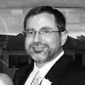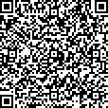

**EVENT STAFF**

**MARK TURNER**

VP of INFORMATION SYSTEMS

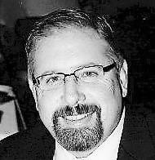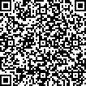

**EVENT STAFF**

**ERIK COVITZ**

WWTC PRESIDENT

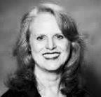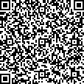

**EVENT STAFF**

**JENA HOFFMAN**

INTIX PRESIDENT & CEO

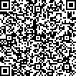

**EVENT STAFF**

**ANNA ZIRBEL**

THC DIRECTOR OF MARKETING

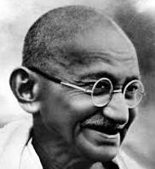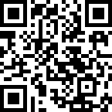

**EVENT STAFF**

**GANDHI**

ALL AROUND NICE-GUY